Kathy Dykstra
1530 County Rd. 259
Rifle, CO 81650

PREMIUM LIST

This premium available on-line http://rmiwa.org/specialty-show-and-performance-trials/

Early entries close on August 29, 2018 at 5:00 p.m.
at the Field Trial Secretary’s address
Day of trial entries close at 7:30 am the day of the trial at the FTS desk.
(Substitutions by the same owner will be allowed by Roll Call the day of the trial)

ASFA SANCTIONED
IRISH WOLFHOUND SPECIALTY LURE TRIAL
REGION 3

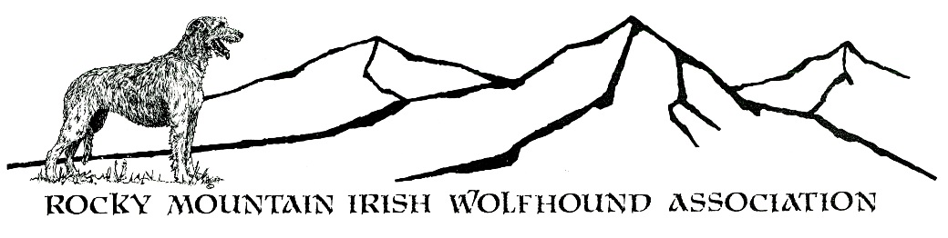
SATURDAY September 1, 2018

Edwards’ Coursing Field
3034 Crazy Horse Road
Cheyenne, WY

Entry Fees:
Early entry: $20.00 for first hound, $12.00 each add'l hound-same owner.
Day of Trial entry: $25.00 per hound
Non-Regular stakes (Breeder, Kennel, Bench CH) $5.00 per unit

Payments via PayPal accepted

Please add $2 to the entry fees and send to Treasurer@RMIWA.org
Send a copy of the PayPal receipt along with your entries to the Field Trial Secretary
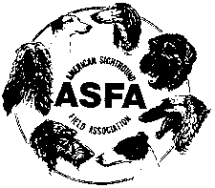

Permission has been granted by the American Sighthound Field Association for the holding of this event under American Sighthound Field Association Rules and Regulations.

Audrey Silverstein, Chairman
ASFA Scheduling Committee

ROCKY MOUNTAIN IRISH WOLFHOUND ASSOCIATION
OFFICERS AND DIRECTORS
President: Denise Shorey Treasurer: Kathy Edwards
Vice President: Michelle Storer-Fujiwara Secretary: Shawna Stone
Brd. of Dir.: Jody Bryan, Michael Hussey, Connie Smalley, Kim Underwood

JUDGES and their assignments
Irish Wolfhounds
Frank Cassano, PO Box 235, La Salle, CO 80645
Claudia Miller, 8205 WQ. 67th Place, Arvada, CO 80004

FIELD COMMITTEE
Field Chairman
George Stone, 6620 Finecrest Dr, Colorado Springs, CO 80923 azendogtraining@gmail.com 719-499-7855 (cell)
Field Secretary
Kathy Dykstra 1530 County Rd. 259, Rifle, CO 81650
kathy@crimsonwireless.com 970-625-3865(H) 970-319-5435(C)

Lure Operator – Leonard Luty

RIBBON PRIZES & TROPHIES
First Place Blue Rosette Second Place Red Rosette Third Place Yellow Rosette Fourth Place White Rosette NBQ Green Rosette
Best of Breed Purple & Gold Rosette Best Single stake winner Navy/gold ribbon
All trophies offered by the RMIWA and its generous donors
Best of Breed: Travel Chair w/ Logo offered by: Stu & Kathy Dykstra
Kennel Stake: Ceramic Mug w/ Logo offered by: Jill Bryson
Breeder Stake: Ceramic Mug w/ Logo offered by: Connie Smalley
Highest Bench Champion Stake: Ceramic Mug w/ Logo offered by: Stu & Kathy Dykstra
1st Place All Stakes: Pint logo glass. 2nd-NBQ All Stakes: RMIWA logo glass
Open Stake trophies offered by Michael Hussey
FCh Stake trophies offered by Connie Smalley
Veteran Stake trophies offered by Jill Bryson
Single Stake trophies offered by Jill Bryson
Perpetual Trophies
Best of Breed: Bronze IW Sculpture on Wood Base - Donated by Kathy & Stu Dykstra
Memory Book of Past BOB winners - Multiple donors
Challenge Trophies
Open 1st place: Silver-plate Bowl on Wood Base - Prairie Creek Trophy - Jim & Connie Smalley
Field Champion 1st place: Silver-plate Bowl on Wood Base - Tralen Trophy – Tracey & Leonard Luty
Veteran 1st place: Trophy– Rockhart Noor Trophy – Shelley & Tom Hood

TRIAL HOURS
6:30AM until completed. Day of Trial entries close at 7:30 a.m. Roll call: at 8:00 AM.

Only purebred Irish Wolfhounds may be entered in the regular stakes in ASFA lure field trials. All hounds must be not less than one year old on the day of the trial. All entries in the regular stakes shall be individually registered with the American Kennel Club (ILP and PAL included), an ASFA-recognized foreign, or ASFA Board approved registry.

REGULAR STAKES OFFERED:
OPEN STAKE: Any eligible Irish Wolfhounds that have met ASFA certification requirements excluding ASFA Field Champions of record.
FIELD CHAMPION STAKE: Any ASFA Field Champion Irish Wolfhounds.
VETERAN STAKE: Any eligible Irish Wolfhounds that have met ASFA certification requirements whose age is at least five years.
SINGLE STAKE: Any eligible Irish Wolfhound including those disqualified to run in other stakes. Each hound runs alone. Not eligible for Best of Breed or Best in Field. Hounds are eligible to earn TCP and CPX titles from the Singles stake. Limited breeds are not eligible for these titles.

The entry for each hound entering the Open or Veteran stake for the first time MUST include a completed & signed ASFA Certification Form or Waiver Form (with proof of title) and a copy of the hound’s registration certificate.

Each hound entered in the Singles stake for the first time must include copy of the hound’s registration certificate.

ENTRIES WILL NOT BE ACKNOWLEDGED BY MAIL OR TELEPHONE. LATE, INCOMPLETE, UNSIGNED OR CONDITIONAL ENTRIES WILL NOT BE ACCEPTED.

NON-REGULAR STAKES
KENNEL STAKE: An entry shall consist of two Irish Wolfhounds, designated at time of entry, in one of the regular stakes being owned and kenneled by the same person.
BREEDER STAKE: Designated at time of entry, two Irish wolfhounds bred by the same individual.
BENCH CHAMPION: For any Irish Wolfhound with proof on file with the ASFA of a conformation champion title from the AKC, CKC or both or a conformation grand champion title from the UKC. To enter this stake, the owner must attach a copy of the hound's show championship certificate to the entry form.

CONDITIONS OF ENTRY:
All entries must be one year or older on the day of the trial. Stakes will be split into flights by public random draw if the entry in any regular stake is 20 or more. Bitches in season, lame hounds and hounds with breed disqualifications will be excused at roll call. Spayed, neutered, monorchid or cryptorchid hounds without breed disqualifications may be entered. Hounds with breed disqualifications are not eligible to enter Hounds not present at the time of roll call will be scratched. All hounds will run twice, in trios if possible or braces (except in the Single Stake), unless excused, dismissed or disqualified.

Please Contact George Stone - Field Trial Chairman about Certification Runs

REFUND POLICY - Refunds will be allowed for lame hounds, bitches in season and breed disqualifications as determined at the trial inspection. Full refunds are allowed for entries cancelled for any reason prior to the EARLY entry closing date and time.

GENERAL INFORMATION and POLICIES: A penalty of $5.00 will be assessed for any loose hound not competing in the course in progress. Battery powered continuous loop machine will be used. Lure will consist of white plastic strips or a combination of black and white plastic strips. Back-up equipment will be available. BRING WATER AND SHADE FOR YOUR HOUNDS. No porta-potty or bathrooms on site. WARNING: It is advised that all hounds entered be in top physical condition due to the altitude and rigorous conditions of the course. ALL HOUNDS RUN AT THE OWNER’S SOLE RISK.

COURSE PLAN: The RMIWA reserves the right to alter the course diagram ONLY as required by weather and/or field conditions on the day of the trial.

690 yards

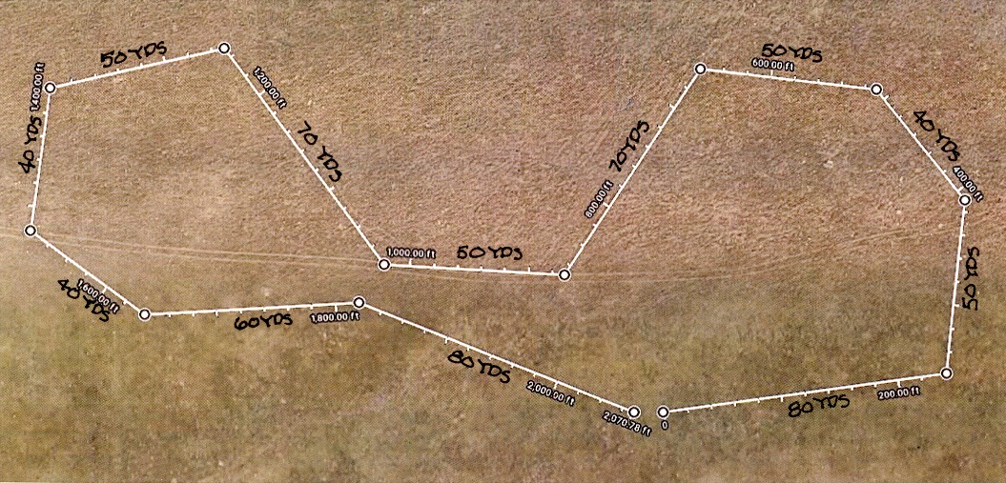

____________________________________________

Directions to Trial Site
From I-25 North or South: Just North of Cheyenne, WY on I-25, go to Exit 16 Horsecreek Rd. Turn right (east) on Horsecreek Road (this changes into Iron Mountain Rd).

Cross Yellowstone Road. Then turn North (left) on Powderhouse Road (dirt road) which is 2 ½ miles from I-25.

Go North on Powderhouse Road 0.5 miles to Sitting Bull. Turn right (east) on Sitting Bull (0.4 miles) to Empire. Turn left (north) on Empire and go 0.8 miles (curving to the right as Empire turns into Crazy Horse) to the entry gate on the left.

Veterinarian in vicinity: Avenues Pet Clinic, 5520 Yellowstone Rd
307-778-3007 24/7 emergency care.

Directions to Vet Clinic from Trial Site
From Powderhouse Road go west to Yellowstone. Turn left or south on Yellowstone stay on it past Vandehei through the signal. Past the Qwest bldg. to Carlson. Clinic is ½ block south of Carlson on right (west) side with a yellow pig with flowers in front and next to Big O Tire.
________________________________________________

Please come to the:
RMIWA Specialty Show and Obedience Trial
August 31, 2018
Island Grove Regional Park
Greeley, CO

Show Secretary: Jan D Curtis
2837 W 49th Street -- Evans CO 80620-9516
Phone / Fax: (970) 339 3272
JDC_ShowSecretary@msn.com

OFFICIAL AMERICAN SIGHTHOUND FIELD ASSOCIATION ENTRY FORM

ROCKY MOUNTAIN IRISH WOLFHOUND ASSOCIATION
SATURDAY, September 1, 2018
Early entries close Wed. August 29, 2018 at 5:00 p.m.
$20.00 for 1st dog, $12.00 ea. add’l dog same owner. $5.00 Non-Regular Stakes
Day of Trial entries close at Roll Call on the day of the trial, $25.00 per dog.
Make checks payable in US funds to RMIWA and mail with entry to:
Kathy Dykstra 1530 County Rd. 259, Rifle, CO 81650

Fee Paid ______ The Field Secretary cannot accept conditional, unsigned, incomplete or unpaid entries; please check your completed entry carefully.
Breed: | Call Name:
Registered Name of Hound:

Stake:  Open FCH Veteran Single Limited |  | Additional Stakes  Kennel Breeder Bench
Registration Number: (please write in registering body before number)

If possible, please  separate my hounds | Date of  Birth: | Sex:  Dog Bitch
Name of actual owner(s):

Address: |  | Phone:
City: |  | State: | Zip:
^{E-mail (Optional)} |  | (Optional) Region of Residence:
Emergency Contact Name and Phone (Optional)

Check if this is the first ASFA trial for this hound. Attach a Hound Certification or waiver if entered in Open, Veterans, Limited.
Check if this is a first-time entry, a copy of the official Registration of this hound must accompany this entry unless NGA.
Check if any information has changed since the last ASFA trial entry. Regarding _______________
Check if this hound has been dismissed within the last 6 trials entered. Must be marked in order to qualify for a “clean” trial requirement.

I CERTIFY that I am the actual owner of this dog, or that I am the duly authorized agent of the actual owner whose name I have entered above. In consideration of the acceptance of this entry and the opportunity to have this dog judged and to win prize money, ribbons, or trophies, I (we) agree to abide by the rules and regulations of the American Sighthound Field Association in effect at the time of this lure field trial, and by any additional rules and regulations appearing in the premium list for this lure field trial. I (we) agree that the club holding this lure field trial has the right to refuse this entry for cause, which the club shall deem to be sufficient. I (we) agree to hold this club, its members, directors, governors, officers, agents or other functionaries, any employees of the aforementioned parties and the owner(s) of the trial premises or grounds harmless from any claim for loss or injury which may be alleged to have been caused directly or indirectly to any person or thing by the act of this dog while in or upon the lure field trial premises or grounds or near any entrance thereto and I (we) personally assume all responsibility and liability for any such claim, and I (we) further agree to hold the aforementioned parties harmless from any claim loss of this dog by disappearance, theft damage or injury be caused or alleged to be caused by the negligence of the club or any of the aforementioned parties or by the negligence of any person or any other cause or causes. I (we) certify and represent that the dog entered is not a hazard to person or other dogs. This entry is submitted for acceptance of the forgoing representations and agreements.

SIGNATURE of owner or his agent
duly authorized to make this entry __________

Please separate the entries before submitting to FTS.
OFFICIAL AMERICAN SIGHTHOUND FIELD ASSOCIATION ENTRY FORM

ROCKY MOUNTAIN IRISH WOLFHOUND ASSOCIATION
SATURDAY, September 1, 2018
Early entries close Wed. August 29, 2018 at 5:00 p.m.
$20.00 for 1st dog, $12.00 ea. add’l dog same owner. $5.00 Non-Regular Stakes
Day of Trial entries close at Roll Call on the day of the trial, $25.00 per dog.
Make checks payable in US funds to RMIWA and mail with entry to:
Kathy Dykstra 1530 County Rd. 259, Rifle, CO 81650

Fee Paid ______ The Field Secretary cannot accept conditional, unsigned, incomplete or unpaid entries; please check your completed entry carefully.
Breed: | Call Name:
Registered Name of Hound:

Stake:  Open FCH Veteran Single Limited |  | Additional Stakes  Kennel Breeder Bench
Registration Number: (please write in registering body before number)

If possible, please  separate my hounds | Date of  Birth: | Sex:  Dog Bitch
Name of actual owner(s):

Address: |  | Phone:
City: |  | State: | Zip:
^{E-mail (Optional)} |  | (Optional) Region of Residence:
Emergency Contact Name and Phone (Optional)

Check if this is the first ASFA trial for this hound. Attach a Hound Certification or waiver if entered in Open, Veterans, Limited.
Check if this is a first-time entry, a copy of the official Registration of this hound must accompany this entry unless NGA.
Check if any information has changed since the last ASFA trial entry. Regarding _______________
Check if this hound has been dismissed within the last 6 trials entered. Must be marked in order to qualify for a “clean” trial requirement.

I CERTIFY that I am the actual owner of this dog, or that I am the duly authorized agent of the actual owner whose name I have entered above. In consideration of the acceptance of this entry and the opportunity to have this dog judged and to win prize money, ribbons, or trophies, I (we) agree to abide by the rules and regulations of the American Sighthound Field Association in effect at the time of this lure field trial, and by any additional rules and regulations appearing in the premium list for this lure field trial. I (we) agree that the club holding this lure field trial has the right to refuse this entry for cause, which the club shall deem to be sufficient. I (we) agree to hold this club, its members, directors, governors, officers, agents or other functionaries, any employees of the aforementioned parties and the owner(s) of the trial premises or grounds harmless from any claim for loss or injury which may be alleged to have been caused directly or indirectly to any person or thing by the act of this dog while in or upon the lure field trial premises or grounds or near any entrance thereto and I (we) personally assume all responsibility and liability for any such claim, and I (we) further agree to hold the aforementioned parties harmless from any claim loss of this dog by disappearance, theft damage or injury be caused or alleged to be caused by the negligence of the club or any of the aforementioned parties or by the negligence of any person or any other cause or causes. I (we) certify and represent that the dog entered is not a hazard to person or other dogs. This entry is submitted for acceptance of the forgoing representations and agreements.

SIGNATURE of owner or his agent
duly authorized to make this entry __________

Please separate the entries before submitting to FTS.

AMERICAN SIGHTHOUND FIELD ASSOCIATION
HOUND CERTIFICATION
Rule effective October 1, 1994: Ch. V, Sec. 4 (a) OPEN STAKE: To be eligible to enter the open stake, a hound must have been certified by a licensed judge within the year preceding the closing date for the entry or have previously competed in the Open Stake. This eligibility requirement also applies to a hound entered in the Limited or Veteran Stake, which has not competed in Open previously. Please complete this portion of this form and attach it to the entry form for the hound’s first entry, including an entry for a Fun Trial.
Registered Name of Hound:
Registration Number: _________________________ Breed:
Registered Owner’s Name:
I hereby certify that on (date) __________________, the above named hound completed a lure course of at least 500 yards, running with another hound of the same breed (or another breed with a similar running style). During the course the above named hound showed no inclination to interfere with the other hound. I further certify that I am a licensed judge for the ASFA.
Name of Licensed Judge: _______________________________________________

Signature:__________________________________________ Date: ___________________
I hereby certify that the hound running in the certification course is the hound identified above and that information provided on this form is true and correct.

Signature: _____________________________________________ Date: _________________
Owner or Authorized Agent of Hound
This certification form must be attached to the entry form the first time this hound is entered in an open, limited, or veteran stake. Any hound entered in open, limited, or veteran (as a first time entered hound), which has not been certified, shall be declared ineligible by the records coordinator and shall forfeit any points and placements awarded.

PLEASE RETAIN A COPY FOR YOUR RECORDS.
AMERICAN SIGHTHOUND FIELD ASSOCIATION
HOUND CERTIFICATION WAIVER

Waiver of Requirement: This requirement will be waived for a hound that has earned a lure coursing or racing title from another recognized organization, if such title requires competition, and if a waiver for such title has been approved by the ASFA, or a CKC Hound Certification Form. If your hound qualifies for a waiver, complete this portion of this form and attach it to your entry form. Proof of waivers must accompany this certification form.

Registered Name of Hound:
Registration Number: _________________________ Breed:
Registered Owner’s Name:
CKC: FCH FCHX CWA: ARX TRP SRA DPC
AKC: QC SC FC LGRA: GRC NAWRA: RCH SR
WRA: CR WRCH NOTRA: ORC OTR SORC SOR
Hound Certification previously submitted.
I hereby certify that the hound identified above has completed the requirements for the title indicated above (or that the required Certification was previously submitted) and that the information provided on this form is true and correct.

Signature: _______________________________________________ Date:
Owner or Authorized Agent of Hound

Sec-06 rev 03/11©

AMERICAN SIGHTHOUND FIELD ASSOCIATION
HOUND CERTIFICATION
Rule effective October 1, 1994: Ch. V, Sec. 4 (a) OPEN STAKE: To be eligible to enter the open stake, a hound must have been certified by a licensed judge within the year preceding the closing date for the entry or have previously competed in the Open Stake. This eligibility requirement also applies to a hound entered in the Limited or Veteran Stake, which has not competed in Open previously. Please complete this portion of this form and attach it to the entry form for the hound’s first entry, including an entry for a Fun Trial.
Registered Name of Hound:
Registration Number: _________________________ Breed:
Registered Owner’s Name:
I hereby certify that on (date) __________________, the above named hound completed a lure course of at least 500 yards, running with another hound of the same breed (or another breed with a similar running style). During the course the above named hound showed no inclination to interfere with the other hound. I further certify that I am a licensed judge for the ASFA.
Name of Licensed Judge: _______________________________________________

Signature:__________________________________________ Date: ___________________
I hereby certify that the hound running in the certification course is the hound identified above and that information provided on this form is true and correct.

Signature: _____________________________________________ Date: _________________
Owner or Authorized Agent of Hound
This certification form must be attached to the entry form the first time this hound is entered in an open, limited, or veteran stake. Any hound entered in open, limited, or veteran (as a first time entered hound), which has not been certified, shall be declared ineligible by the records coordinator and shall forfeit any points and placements awarded.

PLEASE RETAIN A COPY FOR YOUR RECORDS.
AMERICAN SIGHTHOUND FIELD ASSOCIATION
HOUND CERTIFICATION WAIVER

Waiver of Requirement: This requirement will be waived for a hound that has earned a lure coursing or racing title from another recognized organization, if such title requires competition, and if a waiver for such title has been approved by the ASFA, or a CKC Hound Certification Form. If your hound qualifies for a waiver, complete this portion of this form and attach it to your entry form. Proof of waivers must accompany this certification form.

Registered Name of Hound:
Registration Number: _________________________ Breed:
Registered Owner’s Name:
CKC: FCH FCHX CWA: ARX TRP SRA DPC
AKC: QC SC FC LGRA: GRC NAWRA: RCH SR
WRA: CR WRCH NOTRA: ORC OTR SORC SOR
Hound Certification previously submitted.
I hereby certify that the hound identified above has completed the requirements for the title indicated above (or that the required Certification was previously submitted) and that the information provided on this form is true and correct.

Signature: _______________________________________________ Date:
Owner or Authorized Agent of Hound

Sec-06 rev 03/11©

